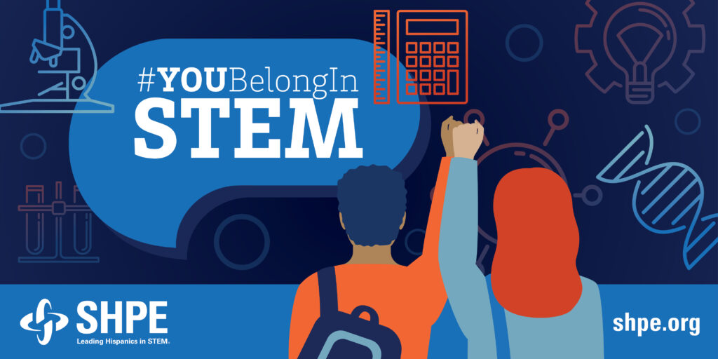

#YOUBelongInSTEM CAMPAIGN

We encourage you to use the graphics provided below in your posts. Whether it’s sharing about your own story and how SHPE gives you a space of belonging in STEM, or by echoing your support for this very important initiative. Here are some ideas:

Suggested Post Copy
As a proud @SHPE member, I support the @US Dept of Education’s effort of ensuring that Hispanic students from PreK to higher education excel in rigorous and joyful STEM learning. #YOUBelongInSTEM #SHPEFamilia
As a proud @SHPE member, I agree with the @US Dept of Education that supporting our STEM educators is critical to developing and growing a stronger and diverse STEM faculty. #YOUBelongInSTEM #HispanicRoleModels
As a proud @SHPE member, I support the @US Dept of Education call for strategic investments towards STEM education and growing the STEM workforce. #YOUBelongInSTEM #HispanicsInSTEM
As a proud @SHPE member, I support the @US Dept of Education’s #YOUBelongInSTEM initiative. Advancing bold actions towards breaking down long-standing barriers will promote student success in all and emerging STEM fields. #HispanicsInSTEM #SHPEFamilia

Relevant Account Tags

SHPE
@SHPE (LinkedIn)
@SHPE (Twitter)
@SHPENational (Instagram)
@SHPENational (Facebook)

US Dept of Education
@usedgov (LinkedIn)
@usedgov (Twitter)
@usedgov (Instagram)
@ed.gov (Facebook)

